BIKE SALES PERFORMANCE ANALYSIS

Project Overview and Business Analysis

Introduction:
The retail industry generates a large amount of data through customer transactions, sales, products, stores, staff, and inventory. Analyzing this data helps businesses understand sales performance, customer purchasing behavior, product demand, and inventory conditions. This project, Retail Sales Analytics, uses Excel, SQL, Python and Power BI to transform raw retail data into meaningful business insights. The project follows an end-to-end data analytics process, from data cleaning and storage to analysis, customer segmentation, visualization, and interactive dashboard reporting.

Objectives of the project
- Clean and prepare retail transaction data for analysis.
- Create a relational structure that supports joins, aggregations and business queries.
- Analyze sales performance across stores, products, customers and staff.
- Understand customer purchase behavior and support customer segmentation.
- Monitor stock levels and identify low-stock products.
- Build an interactive Power BI dashboard for management-oriented reporting

Excel
The Bike Sales Performance Analysis project analyzes sales, customers, products, brands, stores, inventory, and order information using Excel data and Power BI. The objective is to transform raw business data into meaningful insights that can support sales monitoring, product performance evaluation, customer analysis, and business decision-making.
The major tables used in Analysis:
- Orders – contains customer, store, staff, and order information.
- Order Items– contains product quantities and total prices.
- Products – contains product names and product information.
- Stores – contains store details.
- Customers– contains customer information.
- Staffs – contains employee information.
- Stocks – contains product inventory by store.
- Customer Segments – stores customer segmentation information

Excel concepts used
The project demonstrates practical use of:
* Duplicates
* Data type conversion
* Data validation
* Multiple-table joins
* lookups
* Pivot table

SQL
This SQL Project focuses on analysis a bike-store business database using *MySQL*. The project uses multiple relational tables such as orders, order items, products, stores, customers, staff, stocks, and customer segments.
The main objective is to use SQL queries, joins, aggregation, filtering, grouping, sorting, and conditional logic to extract meaningful business insights from the database.
SQL Concepts Used
The project demonstrates practical use of:
* Database creation
* Table relationships
* INNER JOIN
* Multiple-table joins
* SUM()
* COUNT()
* GROUP BY
* ORDER BY
* LIMIT
* WHERE
* CASE
* ALTER TABLE
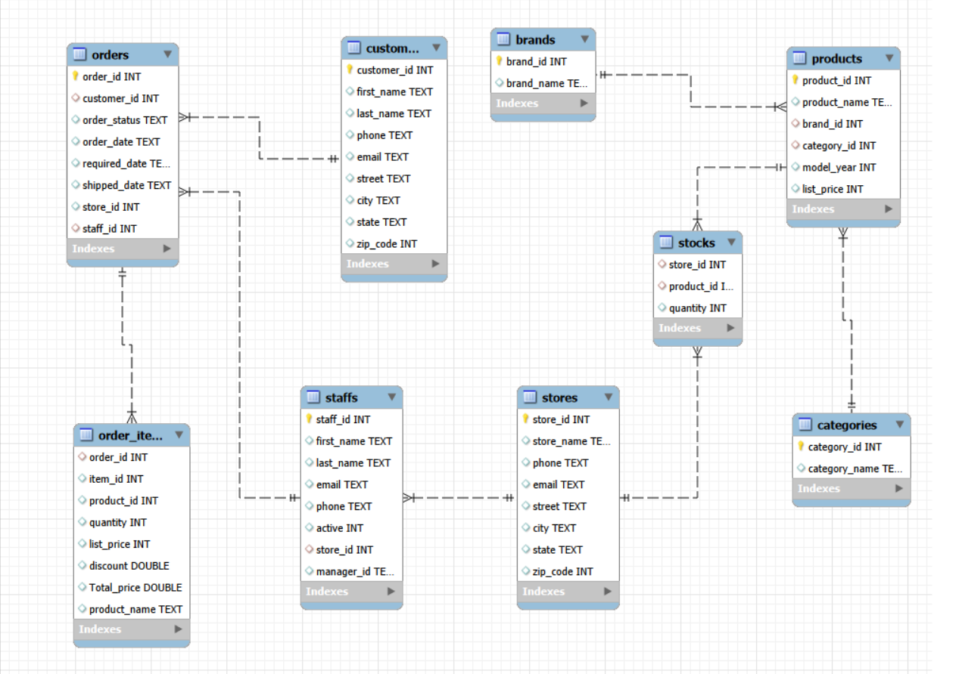

Python (Pandas)
This project analysis a bike sales database using MySQL and Python. The notebook connects to a MySQL database named “capstone”, retrieves multiple business tables, performs basic data inspection and descriptive analysis, combines order, order-item and customer data, and creates customer-level Recency, Frequency and Monetary (RFM) measures
Tools and Technologies
    - MySQL – source database and SQL queries
    - Python – analytical programming environment
    - Pandas – data loading, transformation and aggregation
    - SQLAlchemy / PyMySQL – database connection
    - Matplotlib and Seaborn – visualization libraries used in the notebook
Customer RFM Analysis
A key analytical step is customer segmentation using RFM analysis
    - Recency – number of days since the customer's most recent order.
    - Frequency – number of distinct orders placed by the customer.
    - Monetary – total Total_price associated with the customer's purchases.
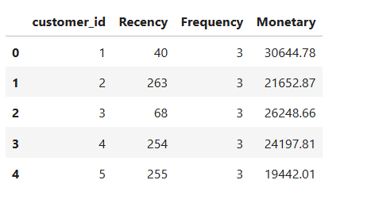

Power BI
The Bike Sales Performance Analysis project is a Business Intelligence and data visualization solution developed using Microsoft Power BI. The primary objective of this project is to analyze bike sales performance and transform business data into meaningful and interactive insights that can support data-driven decision-making.
The dataset contains information about
    - 1,615 orders
    - 1,445 customers
    - 4,722 order items
    - 321 products
    - 9 brands
    - 7 product categories
    - 3 stores

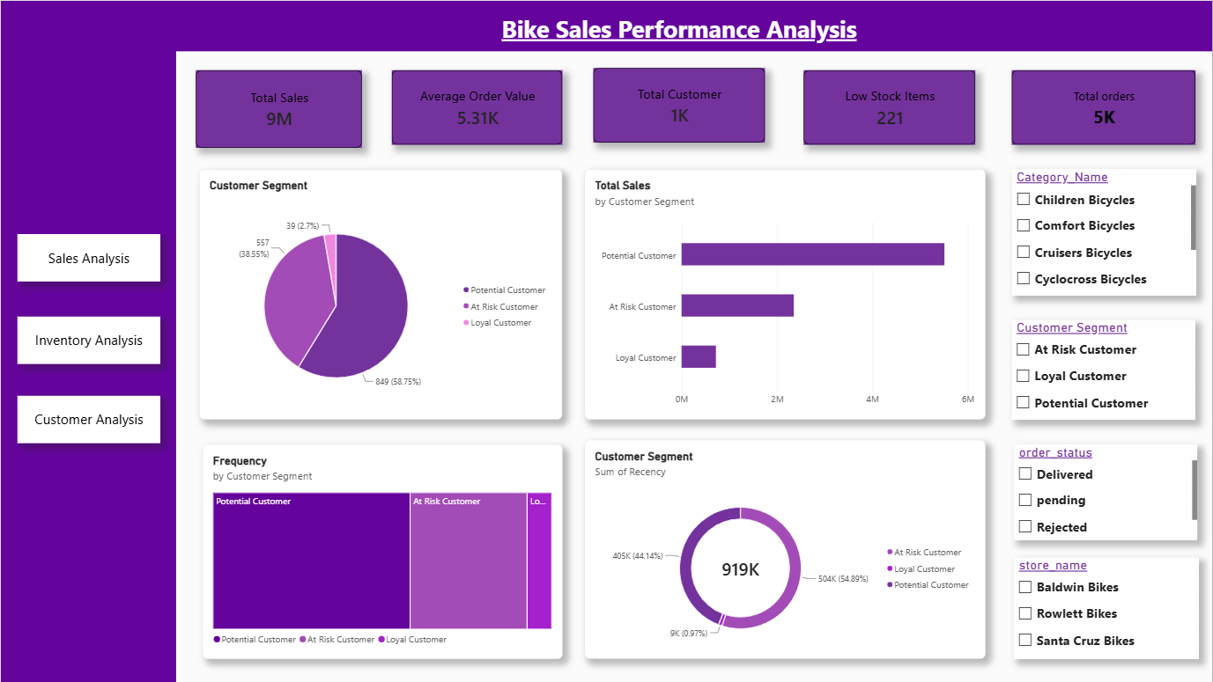

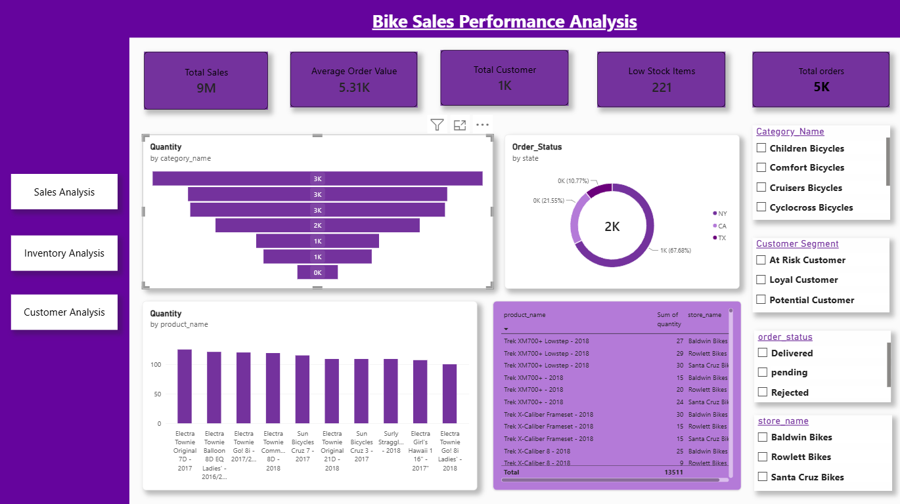
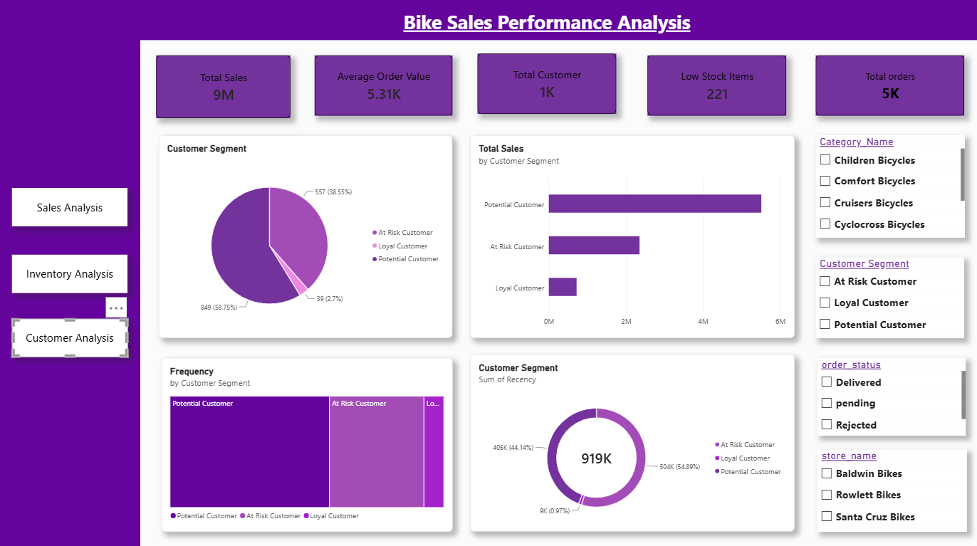

Key insights

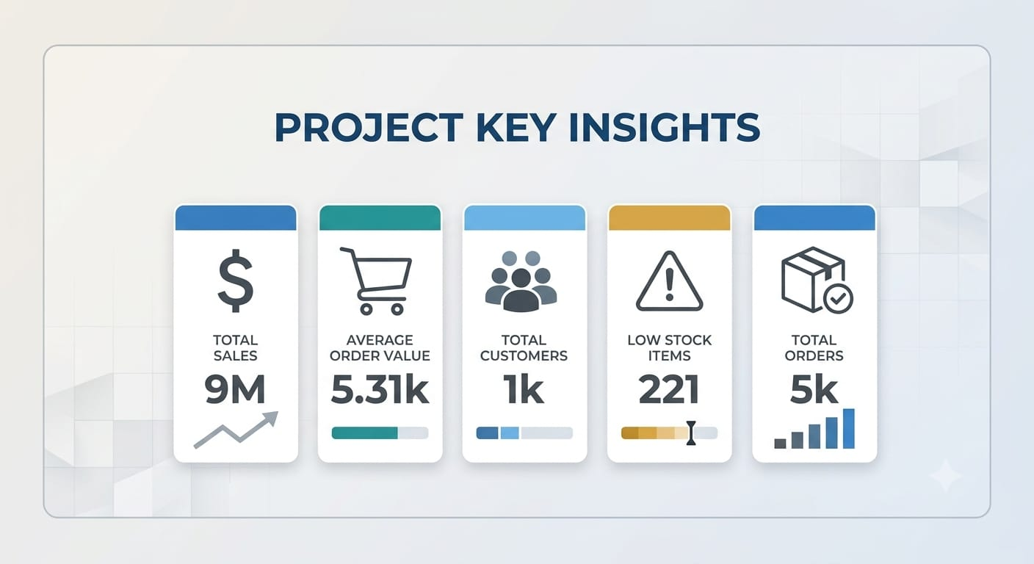

Conclusion
The Retail Sales Analytics project demonstrates an end-to-end data analytics workflow from structured retail data preparation to business intelligence reporting. The project combines Excel, SQL, Python and Power BI concepts to transform transactional data into business-oriented views of sales, inventory and customers.
The final Power BI deliverable provides interactive reporting across Sales Performance, Inventory Insights and Customer Analysis. The project therefore provides a practical example of how a data analyst can move from raw business data to a management-ready dashboard.

